**Creating a PESC Implementation Guide Using XMLSpy**

Don Phillips

January 2016

█ **Summary**

This document and the accompanying Word document “PESC Implementation Guide Template” provide suggestions for creating a PESC standard implementation guide using the features of XMLSpy. This process is based on experience gained from creating the documentation for the PESC Academic ePortfolio standard.

█ **Steps**

The following steps can be followed to create an Implementation Guide using the related PESC Implementation Guide Word template and XMLSpy.

1. Open the document “PESC Implementation Guide Template” in Word. Fix the page footers (see Note below).
2. Update sections 1 to 7 of the template as well as the title page and Version History page.
3. For schema diagrams in section 7 use cropped screen grabs from the XMLSpy schema view.
4. Once the schema authoring is complete and validated in XMPSpy, generate a file of documentation by choosing “Generate Documentation …” from the “Schema design” menu. Use the following settings for generating the documentation. Use the Browse button to select the PESC Implementation Guide SPS design template. A Word document is generated when OK is clicked.

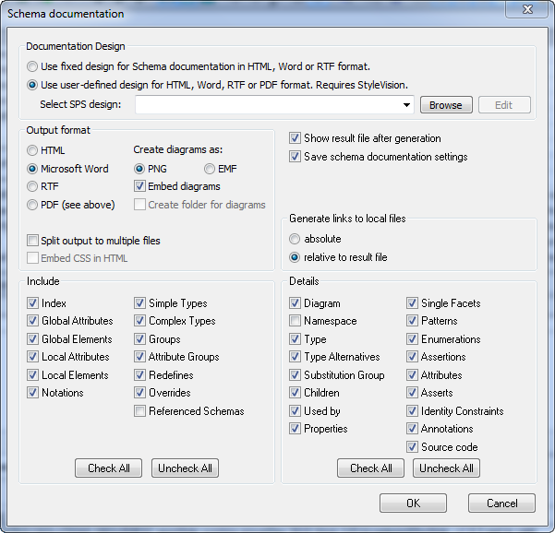

1. Open the documentation file created in step 4. Highlight and copy the content from the index page to the end of the document. Paste this content into section 8 of the template. (The hyperlinks will function properly as bookmarks.)
2. To generate an XML instance document, in XMLSpy choose “Generate sample XML file …” from the “DTD/Schema” menu.
3. Edit the generated instance document then save as a separate XML file for submission once it has been validated.
4. Copy and paste the XML for the instance document into Appendix A of the template. Copying and pasting from XMLSpy retains the indents for readability when pasted into Word.
5. Right click on the Table of Contents text then choose “Update Field” from the pop-up menu. In the “Update Table of Contents” dialog box, click “Update entire table” then click OK.
6. Save the edited Word document as an Implementation Guide.

█ **Note**

There is a bug in Word that appears when using this template document. When the Word document is first opened, the page footer is displayed higher on the page than defined impacting the pagination of the document. To quickly correct, double click on any page footer (the footer will return to its intended position on all pages), then click “Close Header and Footer” in the Word toolbar. The document will repaginate. Unfortunately this step needs to be repeated each time the document is opened in Word.